**Project Design Phase-II**

**Technology Stack (Architecture & Stack)**

|  |  |
| --- | --- |
| Date | 03October 2022 |
| Team ID | PNT2022TMID36340 |
| Project Name | Intelligent Vehicle Damage Assessment and  Cost Estimator for Insurance Companies |
| Maximum Marks | 4 Marks |

**Technical Architecture:**

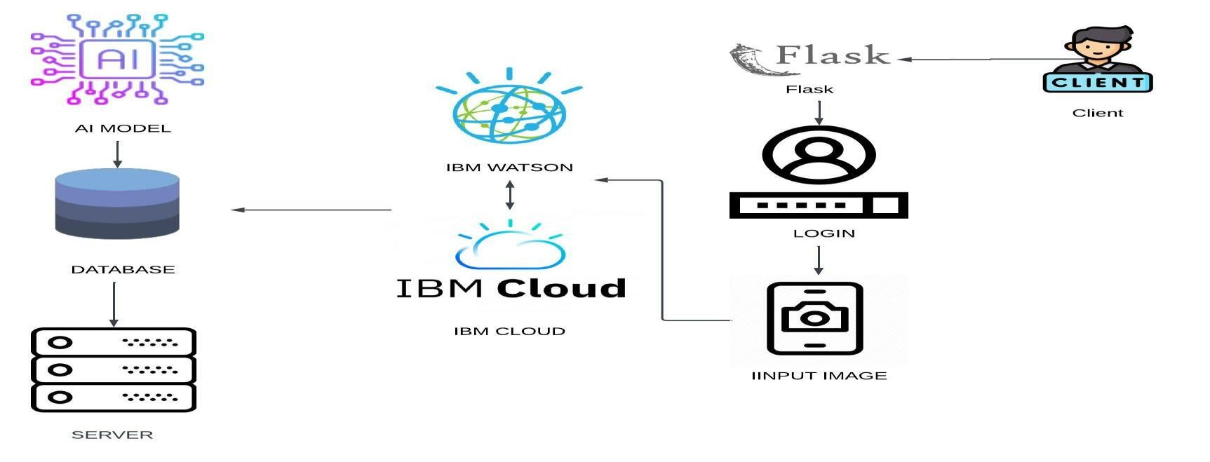

**Table-1 : Components & Technologies:**

|  |  |  |  |
| --- | --- | --- | --- |
| **S.No** | **Component** | **Description** | **Technology** |
| 1. | User Interface | The user interacts with the web application | HTML, CSS, Python |
| 2. | Application Logic-1 | Gets the user input image | Python |
| 3. | Application Logic-2 | Obtaining model output for damage prediction | IBM Watson , Python |
| 4. | Application Logic-3 | Obtaining model output for cost estimation | IBM Watson , Python |
| 5. | Database | Data Type – Details of images and user inputs is stored | MySQL, Js, IBM DB2 |
| 6. | Cloud Database | A database service in the cloud | IBM DB2, IBM Cloudant etc. |
| 7. | File Storage | User details and user input received  The images of the vehicle are stored in the cloud | IBM Block Storage or Other Storage  Service or Local Filesystem |
| 8. | Machine Learning Model | The purpose of the AI model is to estimate cost of the damaged vehicle. | Object Recognition Model, CNN Based model, etc. |
| 9. | Infrastructure (Server / Cloud) | Let's use the AI model on the cloud server  Using Flask on a Web Page | Local, Cloud Foundry, Kubernetes,Python Flask etc. |

**Table-2: Application Characteristics:**

|  |  |  |  |
| --- | --- | --- | --- |
| **S.No** | **Characteristics** | **Description** | **Technology** |
| 1. | Open-Source Frameworks | IBM Watson open source frameworks are used | Open source architecture technology  IBM Watson |
| 2. | Security Implementations | IBM Cloud | ertified Watson Assistant  Encrypted file systems are encrypted Storage systems, key management systems. |
| 3. | Scalable Architecture | Web Server - Static and dynamic website content  Existing on the website will be updated accordingly  User requests and suggestions  Application Server - Basic Upgrade  Integrating website functionality and updates  The logic in the website can be done  Database Server – Based on varying inputs The user supplied database will be modified continuously | IBM Watson Assistant, Python, MySQL |
| 4. | Availability | The AI model is readily available to users any time | IBM Watson Cloud assistance |
| 5. | Performance | IBM Watson - Automated processes, deep  The learning model is trained using IBM Watson  Studio  For better performance and faster access. | IBM Watson Assistant |